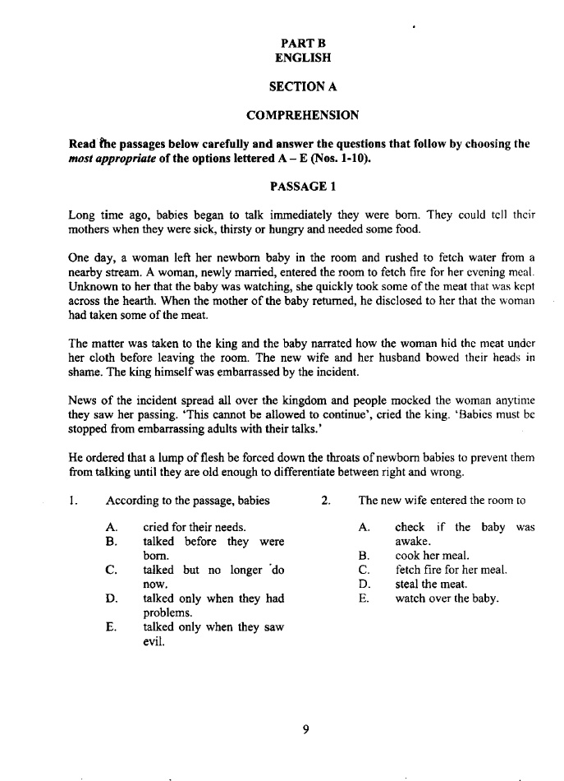

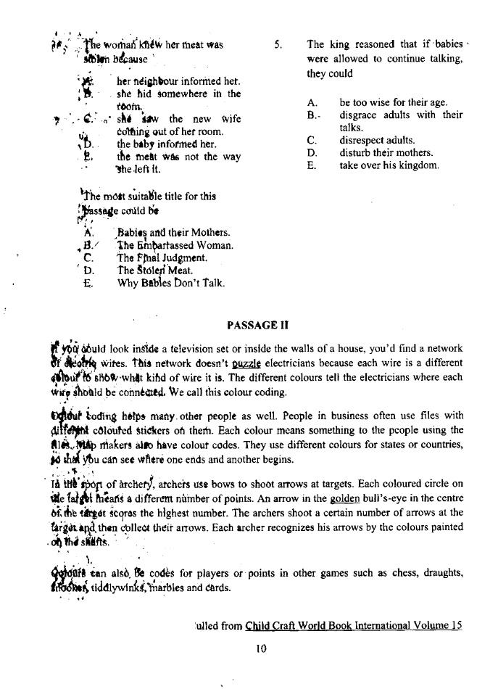
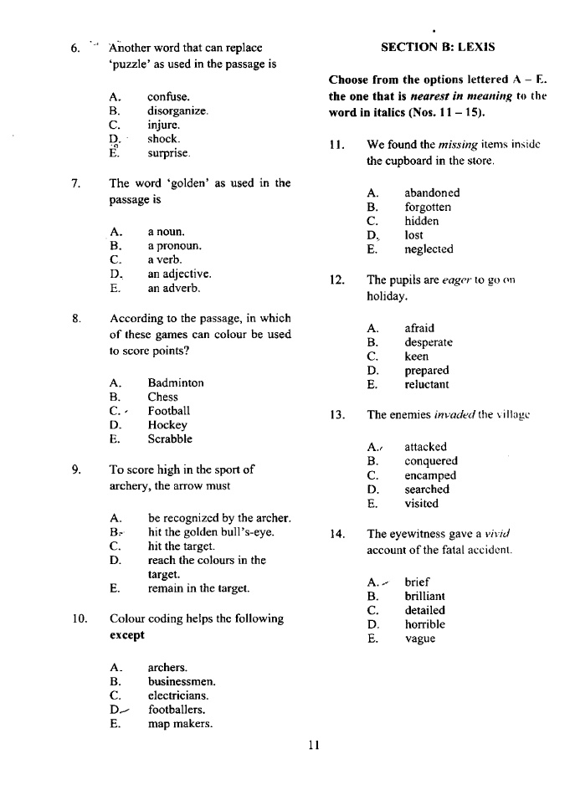
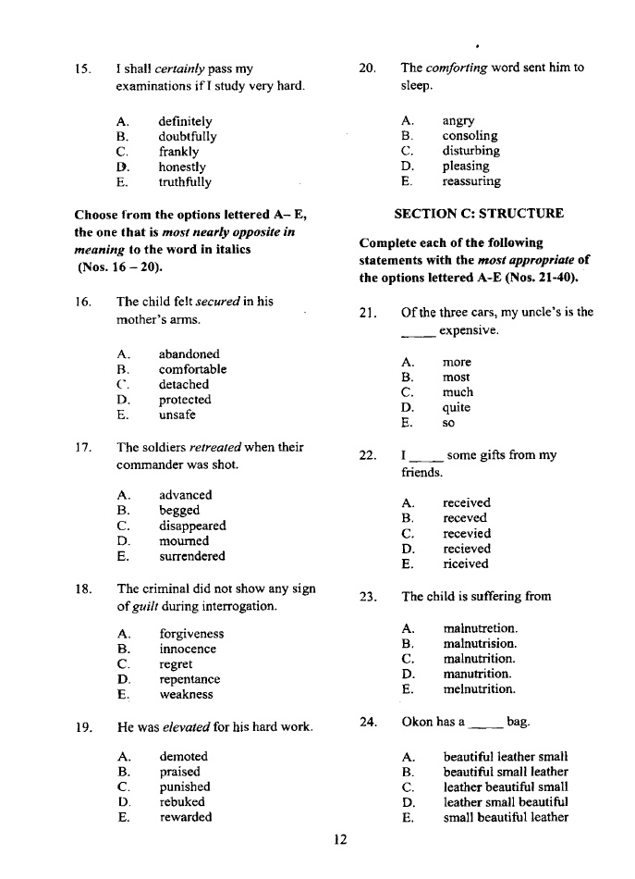
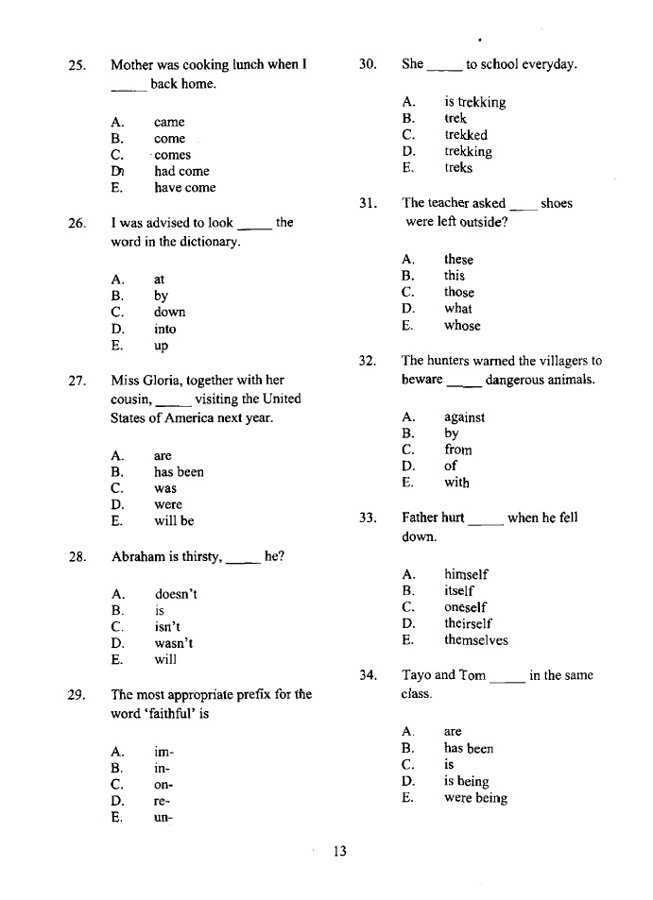
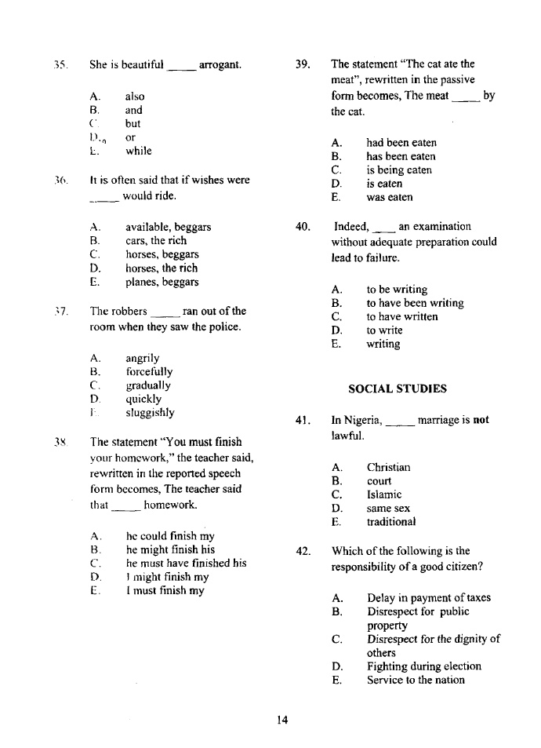

- The south west oil producing state in the South West of Nigeria is _________.
- Lagos (b) Osun (c) Kano (c) Ondo (c) Oyo
- The central bank of Nigeria was established in the year ___________.
- 1957 (b) 1958 (c) 1959 (d) 1960 (e) 1963
- Nigeria became a federation with 36 states in the year ________________.
- 1986 (b) 1976 (b) 1996 (b) 2006 (e) 1012
- Which of the following is a voluntary organization? _________________
- The Nigerian Army (b) The Custom service (c) Police Force (d) Red Cross (e) Prison Service
- The following are values that show nationalism and patriotism except ________________.
- Kindness (b) Intolerance (c) Selflessness (d) Respect (e) Tolerance
- Nigeria is known as __________ Ethnic nation because of the number of languages spoken.
- Multi (b) Dual (c) Tri (d) Quad (c) Octa
- Which of the following is not a national symbol in Nigeria? ___________________
- National Coat of Arms (b) National Library (c) National Vehicle (d) National Currency
- The white colour on the Nigeria Flag symbolizes _______________.
- Peace (b) Power (c) Unity (c) Pride (e) Purity
- The exchange of goods in the olden days is known as ___________.
- Barter (b) Slave Trade (c) Cowries (d) Currency (e) Negotiation
- We have ________ states in Nigeria. (a)12 (b) 14 (c) 16 (d) 32 (e) 36
- The marriage of a man to one woman is known as ________.
- Polygamy (b) Monogamy (c) Di – gamy (d) Octa – gamy (e) Hepta – gamy
- The horse on the Nigerian Coat of Arms represents _____________.
- Agriculture (b) Wisdom (c) Wealth (d) Power (e) Strength

- An unmarried lady is called a/an ___________.
(a) Aunt (b) Spinster (c) Bachelor (d) Farmer (e) Trader
- Which of the following organization has the largest membership?
- A.U (b) ECOWAS (c) NATO (d) U.N.O (c) W.H.O
- A group of people living within a given area of land is called a _________.
- Class (b) Community (c) Company (d) Crowd (e) Family
- Which of the following can be described as a tangible aspect of culture?
- Baskets (b) Languages (c) Morals (d) Values (e) Religion
- Anyone who goes against the law is always ______________.
- Shamed (b) Praised (c) Beaten (d) Punished (c) Banned
- Which of the following is not a means of communication? ____________
- Magazine (b) News (c) Television (d) Radio (e) Telephone
- A man who loves his country is called a _________________. (a) Citizen (b) Comrade (c) Loyalist (d) Patriot
- The following are attributes of a good leader except __________.
- Kindness (b) Love (c) Nationalism (d) Wisdom (e) Foolishness

